PG 1.

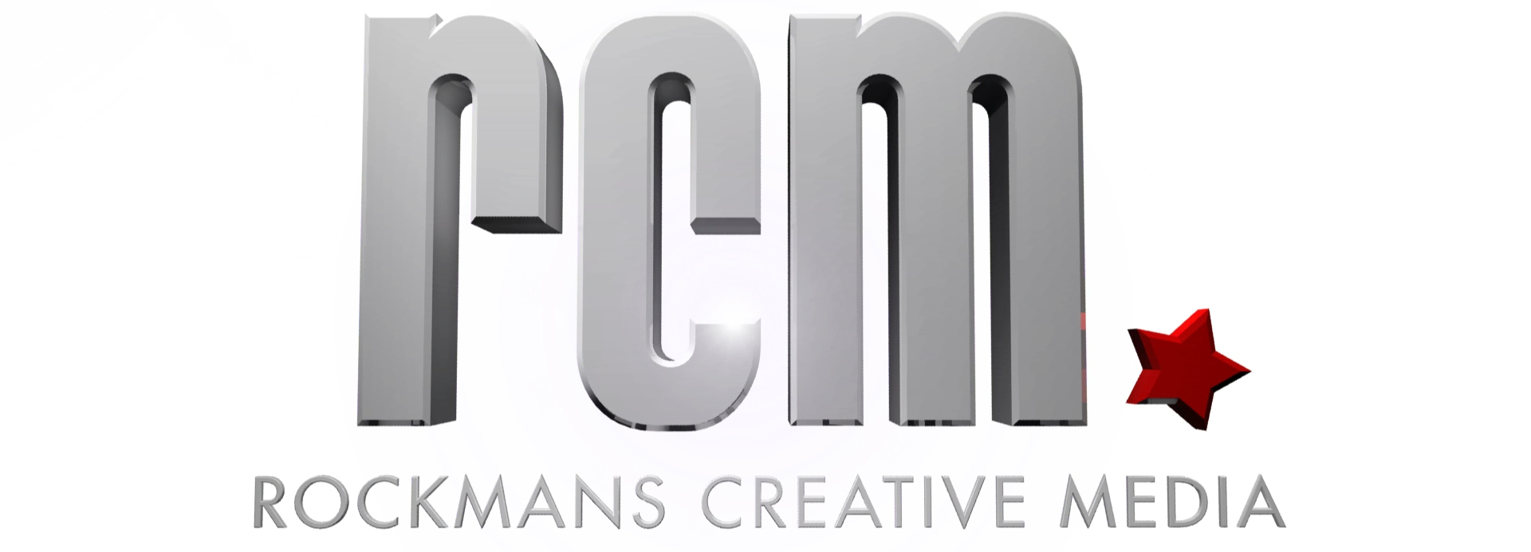
2-892 High Street
Armadale 3143
Victoria, Australia
ABN 21 728 397 689
03 9500 0053
www.RockmansCreativeMedia.com.au

RCM Production Brief Creator.

Here are some questions to ask yourself that will help you work out what you need in your Video
- in fact if you answer as many of these questions as possible and give that to your production company you will be giving them a pretty good brief.
What in the broadest terms do you want your video to achieve? What is its purpose?
examples:
- To let people know about a new product?
- Get people to sign up for your email list?
- Like your facebook page.
- Get the brand out there.

What specific things need to be communicated? List all points.
examples:
- We get rid of dandruff in 24 hrs or you get double your money back.
- Those that sign up will receive discount vouchers with savings worth over $500.
- By liking our facebook page you will enter in the chance for a weekend away for 2 in the Yarra Valley worth $850.
- At acme we make the very best ingenious inventions that are perfect for capturing those pesky road runners.

What is your Target Market?
Paint a picture of the perfect person/people you to watch this Video.
Are they male or female or both?
How old are they?
What sort of job do they have?
What is the highest education they received?
What do they like doing in their spare time?
Do they have any kids? How old?
What do they worry about at night?
What sort of music do they listen to?
What sort of videos do they usually watch?
What books do they read?

PG 2.

RCM Production Brief Creator.

How long do you want your video to be?
Are there any graphic elements or product elements that need to be present?
examples:
- Please keep the logo in the bottom right hand corner the entire time. We would also like to give 5 seconds of screen time to the shampoo bottle.
- Please make sure to have our contact number 123 456 789 for 6 seconds at the end.
- We want to show the video on a landing page with the facebook like button directly underneath so please put a big red arrow (the same colour as our branding) pointing directly below the video for the last 4 seconds of the video.
- This video will be put on YouTube and we will be asking for a subscription and using an annotation, please add a graphic call to action to reflect this.

Do you have a preference for music or the type of voice over?
Give any examples.

How do you imagine the visuals?
examples:
- I would like to see before and after shots of both a man and woman with and without dandruff.
- I’d like to showcase the various products that vouchers give discounts for, with the percentages that they will save.
- I’d like you to source a 25 - 30 year old happy healthy looking spokesman who will deliver the message straight to camera, and then include shots of the Yarra Wacky doo resort (supplied) that the winners will be staying at.
- Our CEO will be the presenter - She wants to demonstrate some of the better Acme Inventions.

Do you need actors; are you using a staff member?

Where will this video be shown?
examples:
- YouTube, Vimeo, social media, channel nine during the midday show.
- Our website home page.
- On a specific landing page that is all about the competition and getting them to like our facebook page.
- As an introduction before the CEO starts his keynote speech in the Las Vegas Road Runner Catchers Convention.
Are there specific dates that the video must run for?

Are there anything that should be avoided?
examples:
- Please do not show balding men or people with dull lifeless hair.
- Do not mispronounce our product name - it’s Sheety Shopping (as in sheet).
- Please do not have any shots of the models drinking any wine.
- It is crucial that you avoid all reference of and to Wile.E. Coyote.

PG 3.

RCM Production Brief Creator.

Do you have any reference videos that you think can help us get an idea of what you want?

What about this example do you like?
examples:
- I like how the voice over is caring and trustworthy and not like a late night infomercial.
- I like how they list the benefits that they receive by flipping them around in 3d.
- I like how it talks to the same audience we’re going for good music and pacing.
- I like how it’s real you can see that the blender is making mincemeat out of that….
….iPhone (did you think we were going to say road runner?)

What about the example do you not like?
examples:

- It’s too long and too slow
- The call to action isn’t clear enough? How do I get these benefits?
- I can’t stand the graphics - it looks like something from that seventies show.
- The presenter comes across like a raving lunatic - of course you have to catch road runners.

ROCKMANS CREATIVE MEDIA

ABN 21 728 397 689 | 2/892 High St Armadale VIC 3143 | 03 9500 0053

www.RockmansCreativeMedia.com.au

